## 08 –Tuple/Set

**Ex. No. : 8.1 Date: 15/5/24**

**Register No.: 231801160 Name: Sathvikha**

**BinaryString**

Coders here is a simple task for you, Given string str. Your task is to check whether it is a binary string or not by using python set.

Examples:

Input:str="01010101010" Output: Yes

Input:str="REC101" Output: No

**For example:**

|  |  |
| --- | --- |
| **Input** | **Result** |
| 01010101010 | Yes |
| 01010110101 | No |

# Program:

a=input() try:

c = int(a) print("Yes")

except:

print("No")

# Output:

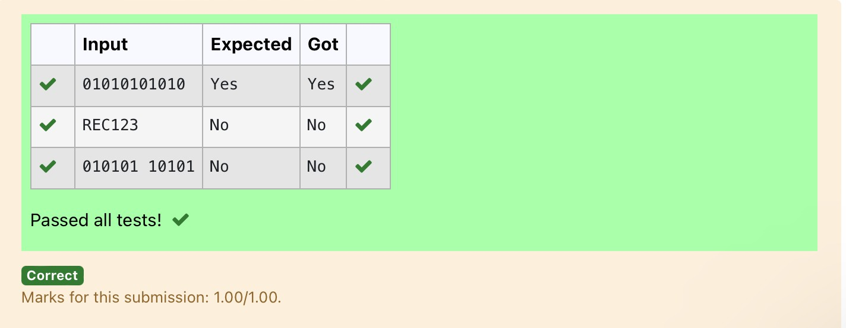

**Ex. No. : 8.2 Date: 15/5/24**

**Register No.: 231801160 Name: Sathvikha**

## CheckPair

Givenatupleandapositiveintegerk,thetaskistofindthecountofdistinctpairsin the tuple whose sum is equal to **K**.

**Examples:**

**Input**:t= (5,6,5,7,7,8),K=13

**Output**: 2 Explanation:

Pairswith sumK(=13)are{(5,8),(6,7),(6, 7)}.

Therefore, distinctpairswithsumK(=13)are{(5,8), (6,7)}. Therefore, the required output is 2.

For example:

|  |  |
| --- | --- |
| Input | Result |
| 1,2,1,2,5  3 | 1 |
| 1,2  0 | 0 |

# Program:

t=input()

k=int(input()) a = t.split(",")

l=[int(x)forxina] count = 0

x=set()

foriinrange(len(l)):

forjinrange(i+1,len(l)): if l[i] + l[j] == k:

s=(l[i], l[j])

ifsnotinxand(l[j],l[i]) notinx: count += 1

x.add(s)

print(count)

# Output:

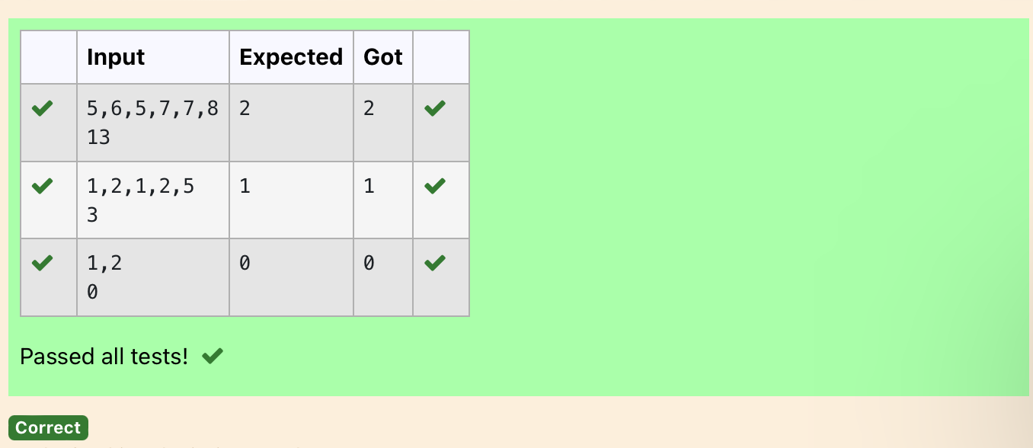

**Ex. No. : 8.3 Date: 15/5/24**

**Register No.: 231801160 Name: Sathvikha**

**DNASequence**

The**DNA sequence**is composed of a series of nucleotides abbreviated as 'A','C','G', and 'T'.

Forexample,"ACGAATTCCG"isa**DNAsequence**.

Whenstudying**DNA**,itisusefultoidentifyrepeatedsequenceswithintheDNA.

Givenastrings thatrepresentsa **DNAsequence**,returnallthe**10-letter- long**sequences (substrings) that occur more than once in a DNA molecule. You may return the answer in **any order**.

**Example1:**

**Input:**s= "AAAAACCCCCAAAAACCCCCCAAAAAGGGTTT"

**Output:**["AAAAACCCCC","CCCCCAAAAA"]

**Example2:**

**Input:**s= "AAAAAAAAAAAAA"

**Output:**["AAAAAAAAAA"]

**For example:**

|  |  |
| --- | --- |
| **Input** | **Result** |
| AAAAACCCCCAAAAACCCCCCAAAAAGGGTTT | AAAAACCCCC CCCCCAAAAA |

# Program:

s=input() j = []

repeated=set()

foriinrange(len(s)-9): sequence = s[i:i+10]if sequence in j:

repeated.add(sequence)

else:

j.append(sequence) l=list(repeated) l=list(reversed(l))

for i in l: print(i)

# Output:

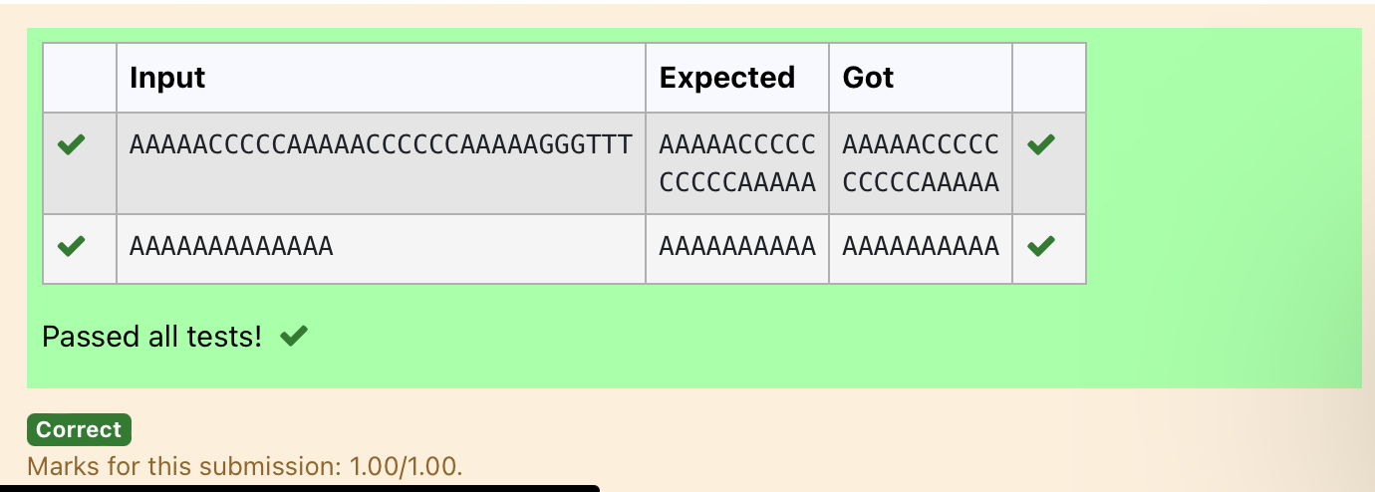

**Ex. No. : 8.4 Date: 15/5/24**

**Register No.: 231801160 Name: Sathvikha**

**Printrepeatedno**

Givenanarrayofintegersnumscontainingn +1 integerswhereeach integerisin the range[1,n] inclusive.Thereisonly **onerepeatednumber**innums, return *this repeated number*. Solve the problem using [set](http://118.185.187.137/moodle/mod/resource/view.php?id=734).

**Example1:**

**Input:**nums=[1,3,4,2,2]

**Output:**2

**Example2:**

**Input:**nums=[3,1,3,4,2]

**Output:**3

**For example:**

|  |  |
| --- | --- |
| **Input** | **Result** |
| 1 3 4 4 2 | 4 |

# Program:

n=input().split("") n = list(n)

foriinrange(len(n)):

forjinrange(i+1,len(n)): if n[i] == n[j]:

print(n[i]) exit(0)

# Output:

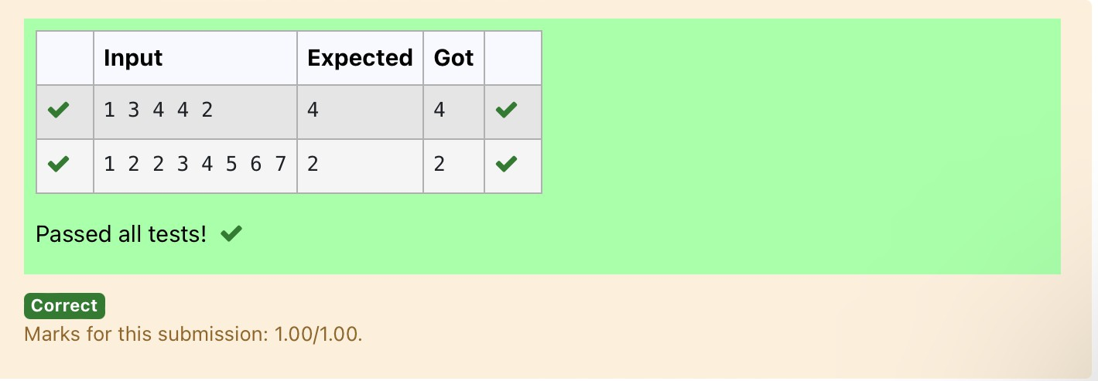

**Ex. No. : 8.5 Date: 15/5/24**

**Register No.: 231801160 Name: Sathvikha**

**Removerepeated**

Writeaprogramtoeliminatethecommonelementsinthegiven2arraysandprint only the non-repeating elements and the total number of such non-repeating elements.

InputFormat:

Thefirstline containsspace-separatedvalues,denotingthesizeofthetwo arraysin integer format respectively.

Thenexttwolinescontainthespace-separatedintegerarraystobecompared.

[Sample](https://www.rajalakshmicolleges.net/moodle/mod/quiz/view.php?id=5127)Input:

54

12865

26810

[Sample](https://www.rajalakshmicolleges.net/moodle/mod/quiz/view.php?id=5127)Output:

1510

3

[Sample](https://www.rajalakshmicolleges.net/moodle/mod/quiz/view.php?id=5127)Input:

55

12345

12345

[Sample](https://www.rajalakshmicolleges.net/moodle/mod/quiz/view.php?id=5127)Output:

NOSUCHELEMENTS

**For example:**

|  |  |
| --- | --- |
| **Input** | **Result** |
| 5 4  1 2 8 6 5  2 6 8 10 | 1 5 10  3 |

# Program:

a=input() d=[]

b=input() c=input()

b=tuple(b.split(""))

c=tuple(c.split("")) for i in b:

if i not in c: d.append(i)

foriinc:

if i not in b: d.append(i)

for i in range(len(d)): print(int(d[i]),end='')

print() print(len(d))

# Output:

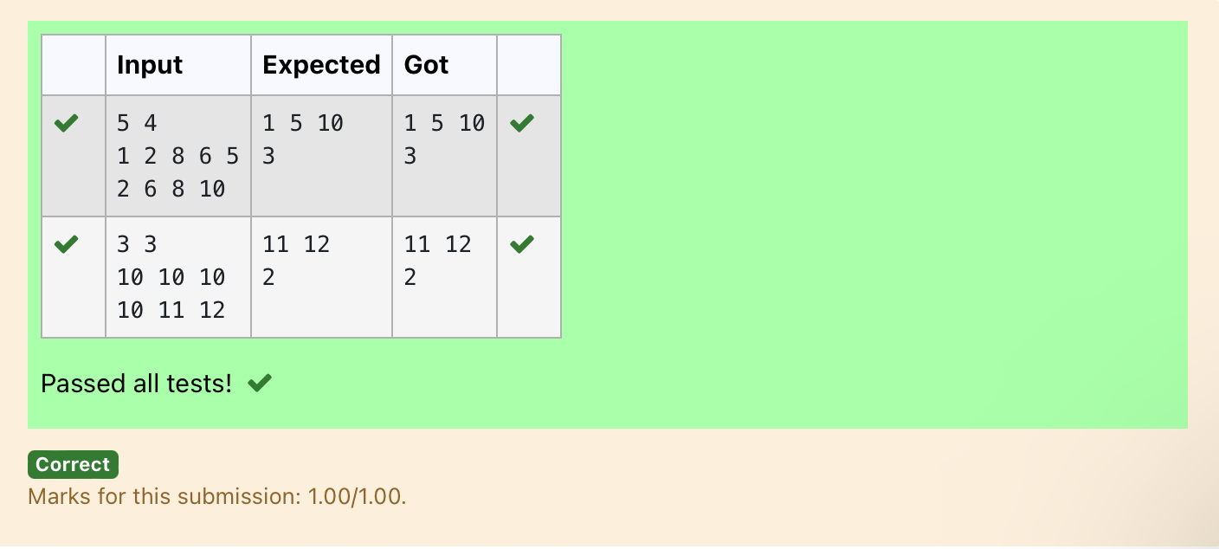

**Ex. No. : 8.6 Date: 15/5/24**

**Register No.: 231801160 Name: Sathvikha**

**MalfunctioningKeyboard**

Thereisamalfunctioningkeyboardwheresomeletterkeysdonotwork.Allother keys on the keyboard work properly.

Given a string text of words separated by a single space (no leading or trailing spaces)andastringbrokenLettersofalldistinctletterkeys thatarebroken,return the number of words in text you can fully type using this keyboard.

Example1:

Input:text="helloworld",brokenLetters="ad" Output:

1

Explanation:Wecannottype"world"becausethe'd'keyisbroken.

**For example:**

|  |  |
| --- | --- |
| **Input** | **Result** |
| helloworld ad | 1 |

Program: **a=input() b=input() c=set()**

**for i in a: forjinb:**

**ifjin i:**

**c.add(i)**

**print(len(c))**

# Output:

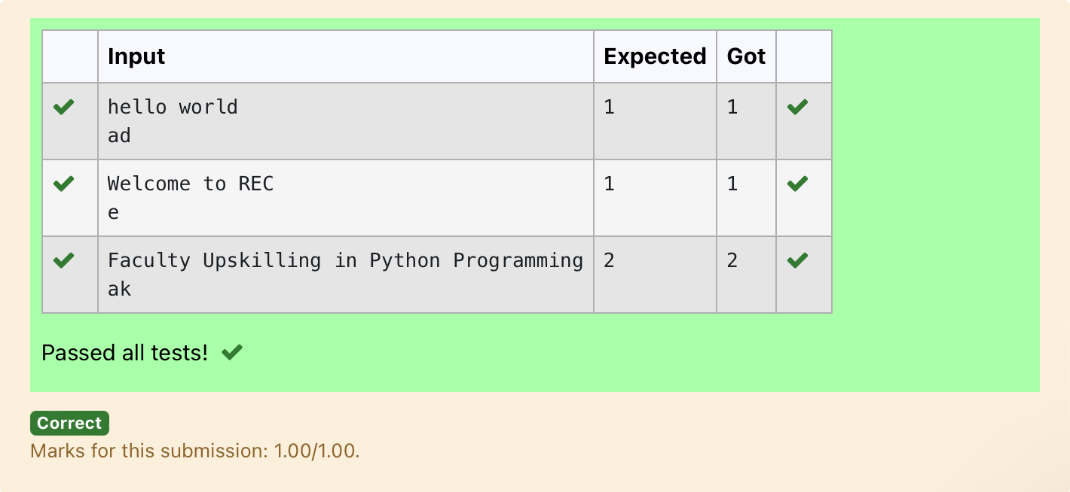

**Ex. No. : 8.7 Date: 15/5/24**

**Register No.: 231801160 Name: Sathvikha**

**Americankeyboard**

Givenanarrayofstrings words,return*the wordsthatcanbetyped usingletters of the alphabet on only one row of American keyboard like the image below*.

Inthe**American keyboard**:

* thefirstrowconsistsofthecharacters"qwertyuiop",
* thesecondrowconsistsofthecharacters "asdfghjkl",and
* thethirdrowconsistsofthe characters"zxcvbnm"

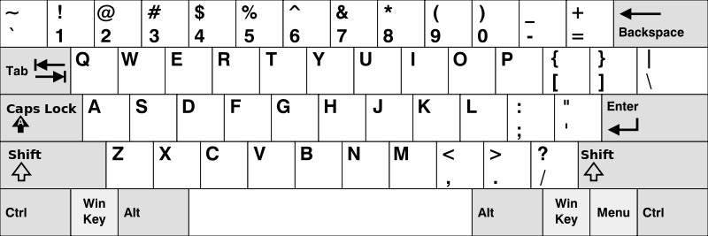

**Example1:**

**Input:**words=["Hello","Alaska","Dad","Peace"]

**Output:**["Alaska","Dad"]

**Example2:**

**Input:**words=["omk"]

**Output:**[]

**Example3:**

**Input:**words=["adsdf","sfd"]

**Output:**["adsdf","sfd"]

**For example:**

|  |  |
| --- | --- |
| **Input** | **Result** |
| 4  Hello Alaska Dad Peace | Alaska Dad |

# Program:

**def findWords(words): row1=set('qwertyuiop') row2 = set('asdfghjkl') row3 = set('zxcvbnm')**

**result=[]**

**forword inwords:**

**w= set(word.lower())**

**ifw.issubset(row1)orw.issubset(row2)orw.issubset(row3): result.append(word)**

**if len(result) == 0: print("Nowords")**

**else:**

**foriinresult: print(i)**

**a= int(input())**

**arr=[input()foriinrange(a)] findWords(arr)**

Output:

